Contact Information:
Serene Singh: 571 206 704
Brayden Donovan: 512 779 2282
Salina Teng 832 992 3218

Locker Information:
Standard Locker LC77
Locker PIN 9354

Subteams CONFIRMED:

Subsystem | Description/ Responsibilities | Team Member
Microtroller + Protocol + DAC | - Protocol for interfacing app to microcontroller  - DAC Amplification/ Setup  - Backend calculations for waveforms | Joe
Amplifier + Filtering + Power | - Amplifying signal  - Filtering Signal  - Power Rails for all components | Salina
FPGA + Memory | - Storing/Reading memory | Brayden
App + Enclosure + Project Management | - Frontend app design  - Calculate waveform based on amplitude and frequency  - Similar Waveform on app | Serene

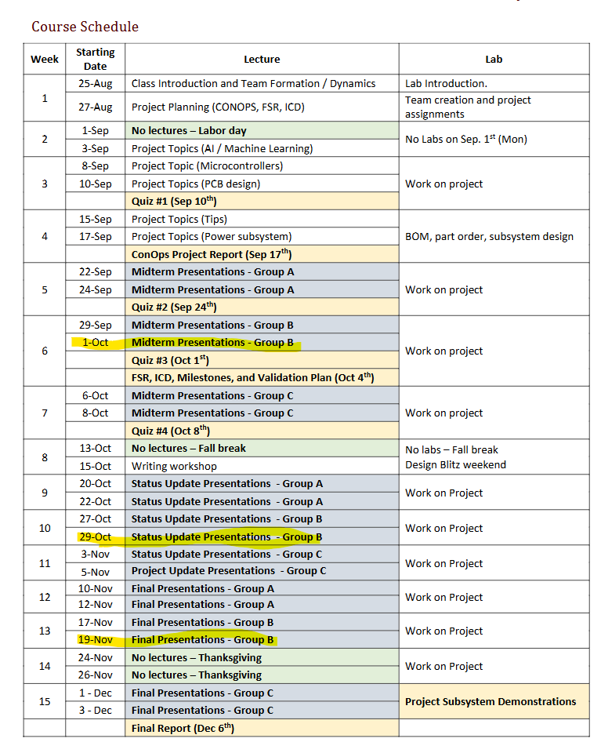

Questions for Lusher
- Ask how many frequencies per signal
  - “Frequency Mixing”
- Current limit for output = 100mA (50% more)
- 50 Ohms output impedance
- Shutdown if overcurrent (bring voltage to 0), opamp has its own shorting (sensor/current meter, diode to limit current)
- Elaborate on drawable
- Should we use to Current- output DAC or Voltage-output DAC

